|  |  |
| --- | --- |
| **Project:** Provisio (Beta) | Module 8 Assignment – Jason, Mishaela, Zach, Scott, and John |
| **Course:** CSD 460 Capstone Project |  |
| **Description:** Test cases for the about us page and the reservation summary page |  |
| **Date:** 2022/11/23 |  |
| **Version:** 0.03 |  |

**TABLE OF CONTENTS**

**Reservation Summary Access** 2

**Reservation Summary Functionality** 4

**About us Page Access** 8

**About us Page Functionality** 8

|  |  |  |  |  |
| --- | --- | --- | --- | --- |
| Test 1 | **Reservation Summary Access** | | | |
|  | **Test Objective: Verify that the reservation summary page can be accessed** | **Developer: Jason Palmeri**  **Date tested:** 2022/11/23 | **Peer tester:**  **Date tested:** <yyyy/mm/dd> | |
| **Step** | **Action** | **Expected results:** | **Developer pass/fail** | **Tester pass/fail** |
| 1 | Go to the landing page | Page should load | yes | <yes/no> |
| 2 | In the URL replace index.jsp with myaccount.jsp | Should redirect you to the home page again | yes | <yes/no> |
| 3 | Go to the login page and enter valid credentials | Should log you in and redirect you to the home page | yes | <yes/no> |
| 4 | Go to My Account | My Account page should load | yes | <yes/no> |
| **Comments** |  | | | |

|  |  |  |  |  |
| --- | --- | --- | --- | --- |
| Test 2 | **Reservation Summary Functionality** | | | |
|  | **Test Objective:** Verify that the summary page functions correctly | **Developer: Jason Palmeri**  **Date tested:** 2022/11/23 | **Peer tester:**  **Date tested:** <yyyy/mm/dd> | |
| **Step** | **Action** | **Expected results:** | **Developer pass/fail** | **Tester pass/fail** |
| 1 | Go to the landing page | Page should load | yes | <yes/no> |
| 2 | Login with valid credentials | Should redirect you to the landing page | yes | <yes/no> |
| 3 | Go to Reservation page and create a reservation | Creating a reservation should redirect you to the My Account page | yes | <yes/no> |
| 4 | Click on your new reservation | A Modal should pop up with your reservation details | yes | <yes/no> |
| 5 | Click on Cancel | You should get a confirmation that it has been cancelled and the reservation should disappear from your list | yes | <yes/no> |
| **Comments** |  | | | |

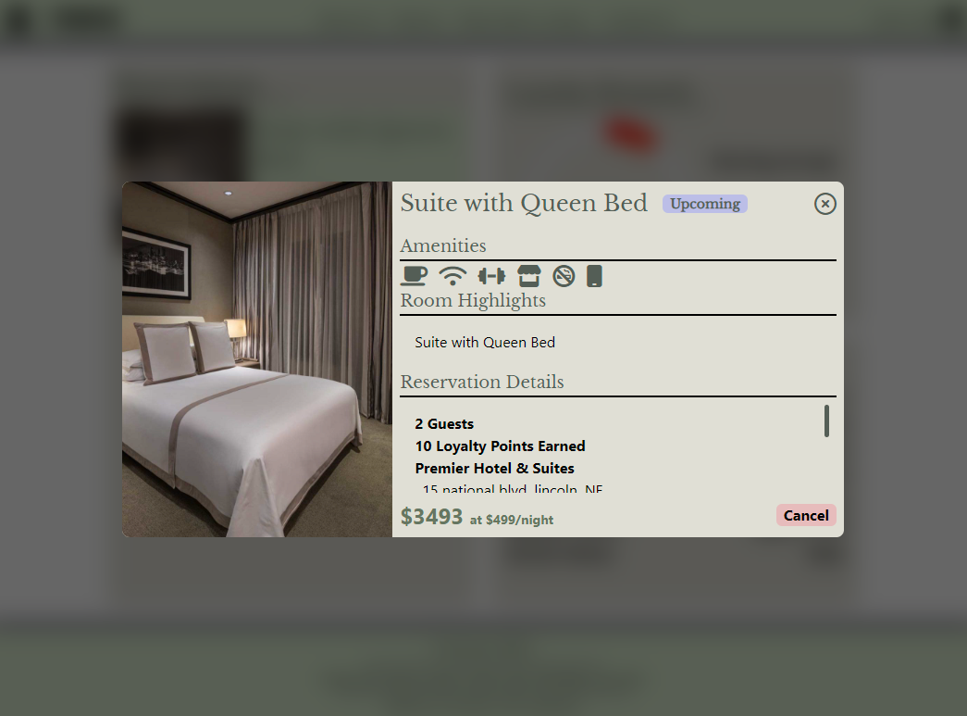

|  |  |  |  |  |
| --- | --- | --- | --- | --- |
| Test 3 | **About us Page Access** | | | |
|  | **Test Objective:** | **Developer:**  **Date tested:** <yyyy/mm/dd> | **Peer tester:**  **Date tested:** <yyyy/mm/dd> | |
| **Step** | **Action** | **Expected results:** | **Developer pass/fail** | **Tester pass/fail** |
| 1 | <Enter an action> | <Enter the expected results> | <yes/no> | <yes/no> |
| 2 | <Enter an action> | <Enter the expected results> | <yes/no> | <yes/no> |
| 3 | <Enter an action> | <Enter the expected results> | <yes/no> | <yes/no> |
| 4 | <Enter an action> | <Enter the expected results> | <yes/no> | <yes/no> |
| 5 | <Enter an action> | <Enter the expected results> | <yes/no> | <yes/no> |
| **Comments** | Comments should be substantive; this means there should be at least 2-3 well-structured sentences with constructive feedback. | | | |

|  |  |  |  |  |
| --- | --- | --- | --- | --- |
| Test 4 | **About us Page Functionality** | | | |
|  | **Test Objective:** | **Developer:**  **Date tested:** <yyyy/mm/dd> | **Peer tester:**  **Date tested:** <yyyy/mm/dd> | |
| **Step** | **Action** | **Expected results:** | **Developer pass/fail** | **Tester pass/fail** |
| 1 | <Enter an action> | <Enter the expected results> | <yes/no> | <yes/no> |
| 2 | <Enter an action> | <Enter the expected results> | <yes/no> | <yes/no> |
| 3 | <Enter an action> | <Enter the expected results> | <yes/no> | <yes/no> |
| 4 | <Enter an action> | <Enter the expected results> | <yes/no> | <yes/no> |
| 5 | <Enter an action> | <Enter the expected results> | <yes/no> | <yes/no> |
| **Comments** | Comments should be substantive; this means there should be at least 2-3 well-structured sentences with constructive feedback. | | | |